ZhongJun Qian
301541827
Instructor: Andrew Hawsushkewich
Course: IAT 339 Web Design & Development Directed Studies
DIRECTED STUDIES FINAL REPORT

Contents
Abstract 2
Pipeline Overview 2
Phase 1: Capturing Layout Structure 2
Phase 2: WFC Layout Generation 5
Phase 3: NLP Text Synthesis 8
What Worked 9
Where the Approach Failed 10
Lessons and Future Direction 10

Abstract
This project explored whether realistic phishing-style websites could be generated automatically from data rather than hand-built templates. Phase 1 built a deterministic RGB capture pipeline that encodes real sites into banded spatial statistics and element-type heat maps. Phase 2 used a Wave Function Collapse (WFC) engine and deterministic “denoising” passes to turn these statistics into multi-band wireframes. In parallel, an NLP module from IAT 360 generated site names and section copy using a retrieval augmented large language model.
Each part worked on its own, but the full pipeline did not achieve the goal of a reliable push-button phishing site generator. Tile-level WFC driven solely by adjacency and band statistics could not reconstruct the higher-level structure of real websites. Over time, more and more handwritten rules were added, indicating that the chosen algorithm did not fit the problem very well.

Pipeline Overview

Phase 1: Capturing Layout Structure
The pipeline begins by encoding each page with a fixed RGB mapping: red for DOM identity, green for semantic type (text, media, button, and so on), and blue for the vertical band index.
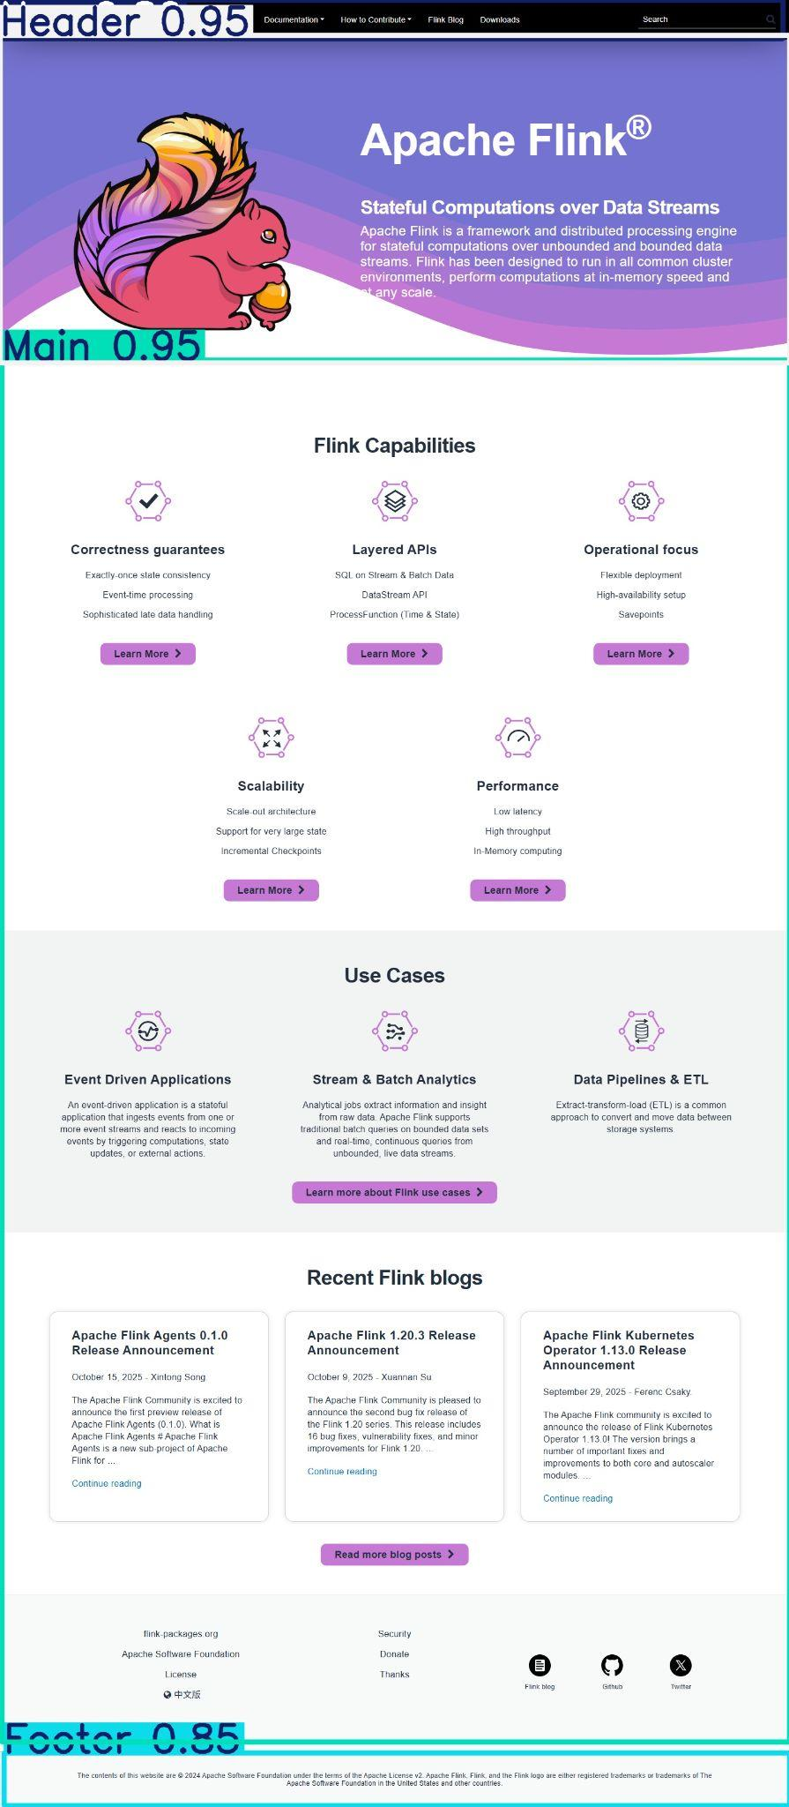
Figure 1 Apache Flink reference site with header, main, and footer bands highlighted by YOLOv8 computer vision model
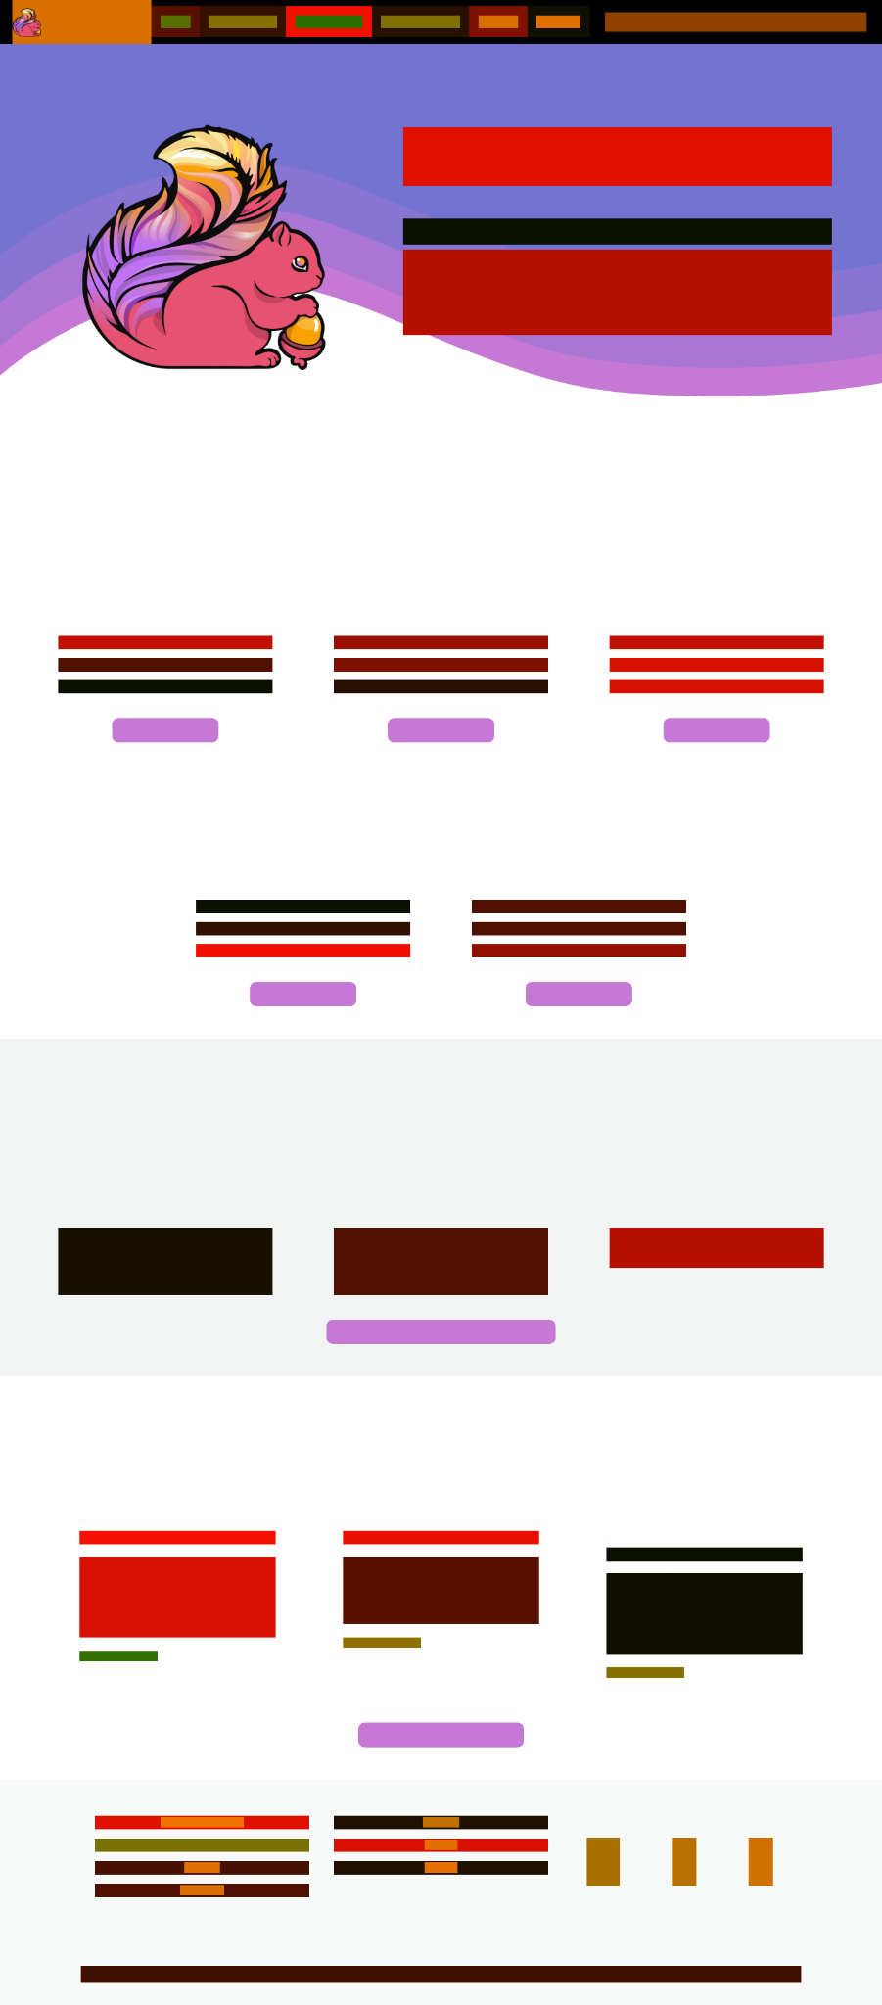
Figure 2 Encoded block abstraction of the same page, showing headings, paragraphs, icons, and buttons
Figure 1 uses the Apache Flink website as an example and shows how the band detector isolates the header, main, and footer regions and reports high coverage scores. Figure 2 abstracts the same page into coloured blocks that represent headings, paragraphs, icons, and buttons. This shows how a visually rich layout is reduced to a small set of element roles.
Across 200 reference sites, the system then builds per-band grayscale masks and aggregates them into element-type heat maps for buttons, media, select boxes, and other controls. Figures 3 to 5 show examples for Main/buttons, Main/media, and Main/select. Brighter areas indicate where those elements most often appear in the main band of documentation style pages. These maps are later used as priors (how much of each type should appear in a band) and as adjacency evidence (which types tend to touch each other).

Figure 3: Main band button heat map showing common call to action positions
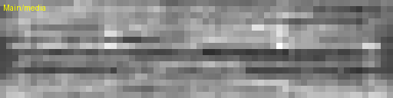
Figure 4: Main band media heat map showing everyday hero and illustration areas

Figure 5: Main band select heat map showing where dropdown controls tend to appear

Phase 2: WFC Layout Generation
Phase 2 tries to rebuild layouts from these statistics using a three-stage generator.
First, tile level WFC is run separately for each band (Header, Nav, Main, Supplement, Footer). For a given band, WFC fills a grid with abstract types such as text, media, and buttons based on adjacency tables and band-specific priors. Figure 6 shows this raw output. Although the grid respects the statistics, it appears to be coloured noise rather than a clear layout.
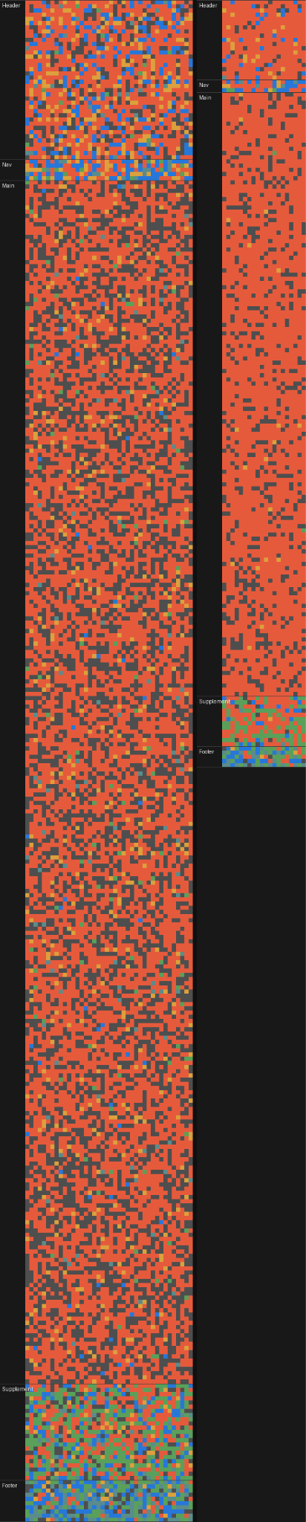
Figure 6 Raw WFC tile grid for a full page, showing a noise-like distribution of text and media tiles
Second, a zone orchestration stage cleans this up. A pooling step merges 2x2 tiles and smooths small fluctuations. The pooled grids are then grouped into larger zones, such as logo areas, hero regions, and card rows, using a rule file derived from common patterns in the dataset. Figures 7 and 8 show two different zone maps produced from similar WFC noise. Red areas indicate text-dominant regions, while orange and blue rectangles mark hero media and content zones. These figures highlight both the strength and the fragility of the method: the same rules can produce believable hero and card layouts, but small changes in the underlying noise can reshuffle zones in ways that do not feel intuitive.
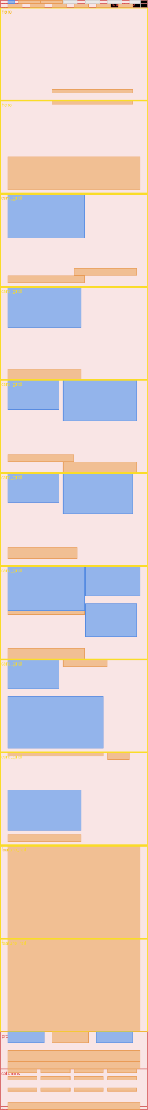
Figure 7 Zone map variant A with hero, card rows, and footer zones detected from pooled WFC output
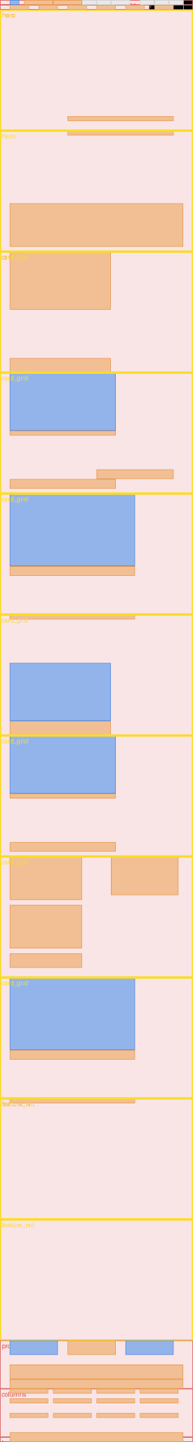
Figure 8 Zone map variant B from a similar seed, showing different hero and card arrangements
Third, a child population stage fills each zone with concrete elements. Card tiles, headings, and buttons are placed using median widths, heights, and densities measured in Phase 1. This geometry guidance helps maintain reasonable proportions, even when the parent zones are not perfect.

Phase 3: NLP Text Synthesis
The NLP module is a separate Python tool. It generates a site name, a hero title and subtitle, and a section plan with paragraphs for each section. The text is conditioned on retrieval augmented snippets drawn from the same corpus used in Phase 1. Character budgets for each text block are estimated from the grid area assigned to that block, so the copy roughly fits when rendered in HTML and CSS.
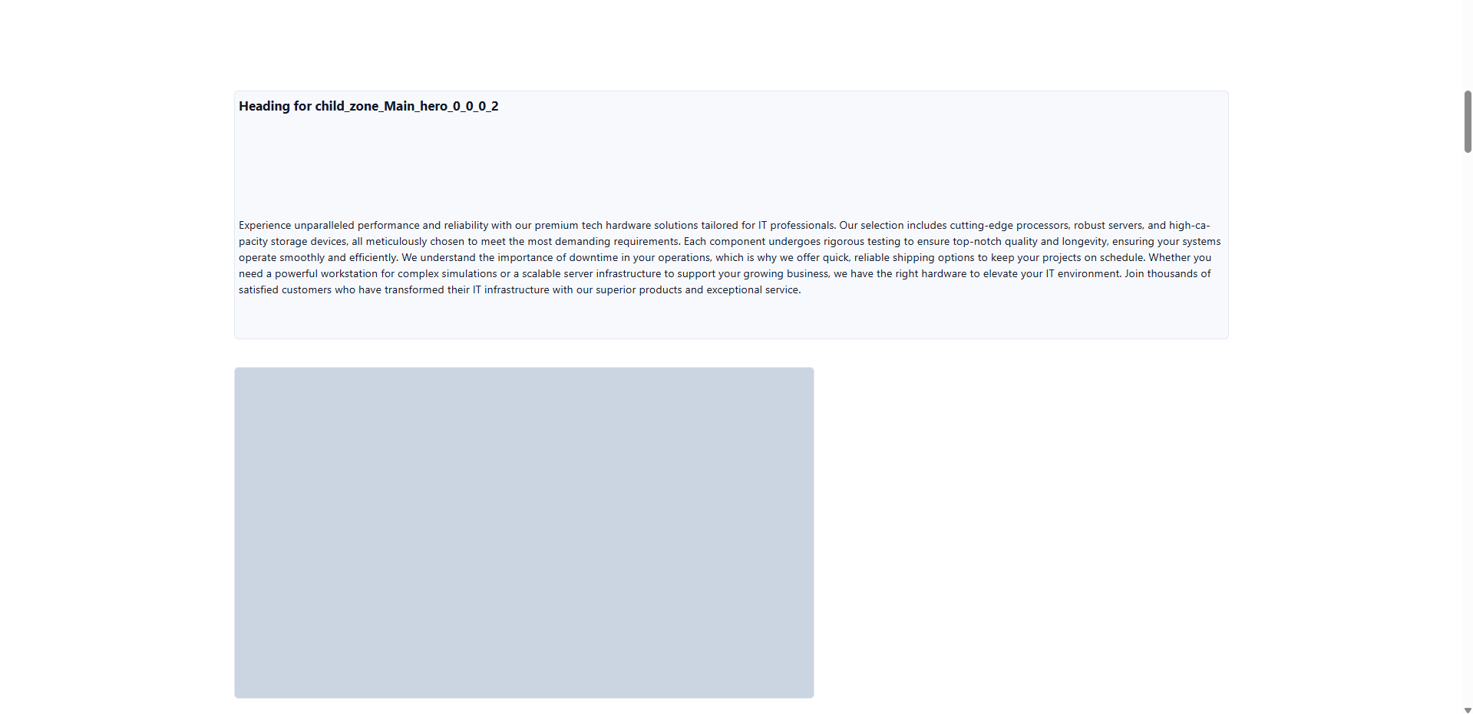
Figure 9 Hero zone rendered in HTML with generated heading, paragraph, and prominent media placeholder
Figure 9 shows a hero zone rendered in HTML with a generated heading, a paragraph, and a prominent media placeholder. When the layout and text align in this way, the system can produce believable vertical slices of a phishing-style landing page.

What Worked
The deterministic RGB capture and band extraction stages produce consistent, usable spatial maps across all sites. This replaces earlier, less reliable computer vision segmentation and gives a solid data foundation.
Solving WFC separately per band and enforcing a fixed vertical order prevents the early failure mode where header-like and footer-like content wander into the middle of the page.
For some random seeds, the full Phase 2 pipeline (WFC, zone orchestration, and child population) generates layouts with clearly recognisable heroes, card rows, and footers, especially when compared side by side with real reference sites.
On the text side, the staged NLP pipeline produces coherent site names and section copy that can be dropped into individual bands and zones. In the best cases, as shown in Figure 9, the combined layout and text look close to a real marketing page.

Where the Approach Failed
Even with these successes, the system does not yet behave as a reliable end-to-end phishing layout generator.
Tile-level WFC cannot express layout hierarchy. The adjacency tables state which element types may touch, but they do not describe larger components such as “hero with media left and text right” or “3 x 2 card grid”. Early outputs looked like coloured noise rather than clean layouts, and later stages had to infer the structure from that noise.
The design order is effectively inverted. Human designers choose components first, for example, navigation, hero, card sections, and footer, and then place them on a grid. In this pipeline, WFC first produces a detailed lattice of element types, and only afterwards do the zone and population stages try to interpret that lattice as components. Figures 6 to 8 show how sensitive this interpretation is to small changes in the underlying noise.
There is also a drift toward an expert system. To stabilise outputs, more and more knowledge is moved into handwritten rule files and geometry heuristics, such as how many nav items to expect, how wide hero media may be, and how card grids should split columns. At that point, WFC mainly introduces randomness, and simpler template-based or component-based generators might be easier to control and explain.
Finally, the coupling between layout and text is loose. Because of API limits and the cost of running the full staged NLP pipeline, the language model is often used only for headings and a few sections, with the remaining text drawn from an offline corpus. Character budgets based on grid area usually work, but sometimes the paragraphs feel visually too long or too short for their allocated boxes.
Taken together, these issues show that adjacency statistics and WFC alone are not enough to build convincing layouts at scale. Significant deterministic correction is required to obtain acceptable samples, which weakens the original goal of a mainly data-driven generator.

Lessons and Future Direction
Three main lessons guide the next steps.
First, future work should model components rather than individual tiles. Instead of asking WFC to place raw text, media, and button tiles, the generator should work with a small library of components, such as navigation variants, hero patterns, card grids, and footers that are derived from Phase 1 statistics. If WFC remains in the system, it should be limited to local decoration inside these components, not global layout decisions.
Second, it would be helpful to use section-level embeddings and a simple sequence model. Each band or section can be summarised as a compact vector describing its band type, component type, media ratio, and card count. A small transformer-style model could then learn common sequences of these section tokens, for example, Nav -> Hero -> Cards -> Footer, and sample new layout plans that are structurally sound.
Third, the generator should include explicit evaluation and repair. Simple metrics such as alignment, whitespace balance, and media-to-text ratios per band can be used to score a layout and either accept it or fix it, instead of accepting every WFC sample.
Even though the current system is not ready for automated phishing at scale, it provides a clear negative result and a concrete roadmap. The Phase 1 data pipeline and the NLP module are worth keeping. However, the global tile-level WFC core should be replaced with a component-based, section-aware generator that reflects how real websites are actually designed.

